Cadorna, Joeffrey June 27, 2025
BSCS – 1 (CBM)
MP1 : Improved Java Code Calculator (converted into Python)
- Code

class Calculator:
def my_oprt(self, a, b, choice):
if choice == 1:
return a + b
elif choice == 2:
return a - b
elif choice == 3:
return a * b
elif choice == 4:
if b != 0:
return a / b
else:
return "Error: Division by zero!"
elif choice == 5:
if b != 0:
return a % b
else:
return "Error: Division by zero!"
else:
return "Invalid operation"

def show_menu(self):
print("************************")
print("Welcome to Mr. Calculator")
print("1 - Add\n2 - Subtract\n3 - Multiply\n4 - Divide\n5 - Remainder\n6 - Exit")

def main():
calc = Calculator()
while True:
calc.show_menu()
try:
choice = int(input("Enter your choice: "))
except ValueError:
print("Invalid input. Please enter a number.\n")
continue

if 1 <= choice <= 5:
try:
a = float(input("Enter first number: "))
b = float(input("Enter second number: "))
result = calc.my_oprt(a, b, choice)
print("Result:", result)
except ValueError:
print("Invalid number. Try again.")
elif choice == 6:
print("Bye!")
break
else:
print("Invalid choice. Try again.")

print()

if __name__ == "__main__":
main()

- Programiz Link: https://www.programiz.com/online-compiler/9ZzZbRSvdcluA

- Narrative
For this activity, we or rather I have converted the calculator we have coded in Java yesterday into a Python code. Where some of the objects, variables, parameters, or alike have been changed, such as this statement in java is declared as a self in python language, as well as the importance of spacing in python compared to java.
Moving on to the narrative proper. I first created a new class called Calculator, that then groups together all the methods which are related to performing operation and displaying the menu for the Calculator.
Second, I created the Method which is the my oprt(self, a, b, choice) which would be the mathematical operation based on what will the user will input or choose, with the Parameters being that a is the first number, b the second number, and the choice operation to be selected between the options 1-6.
Which I then assigned or mapped out to the switch or if and elif statements for the actual computation or operations that the program will use.
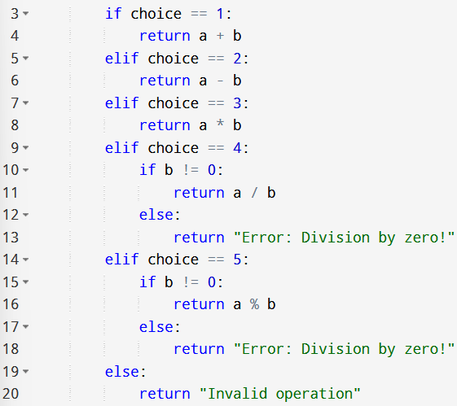
In addition to the Method, I’ve also included the show_menu(self) which displays the menu options for the user, with slight modifications added in the code, such that it would be shorter yet still is intact (instead of having individual print for the Addition, Subtract, Multiply, etc. per line, I’ve made use instead of the \n[number] which we had previously had used and was thought on our comp prog 1 subject.) which made it easier to understand and look, since it only utilizes few lines without having to make use of several lines.
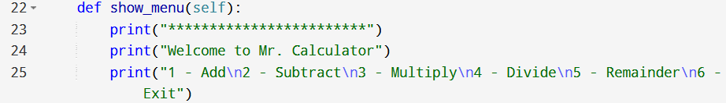
Moreover, there is also the Main Function which is the def main() calc = Calculator() while True: which controls the flow of the program as well as handling the user interaction.
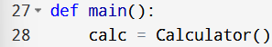
A while True loop keeps the calculator running, unless the user prompts/chooses 6 or exit. The choice = int(input(: “)) prompts the user to select an operation of their choice. If an invalid input is entered (ex. A number that is not within the options), it catches the ValueError. The if 1 <= choice <=5: a = float(input(“Enter first number: “)) b = float(input(“Enter second number: “)), it gets two numbers as floats and calls the my_oprt() method. While the elif choice == 6: print(“Bye!”) break exits the loop and ends the program. On the other hand, the else: print(“Invalid choice. Try again.”) catches any out-of-range choices from the user input.
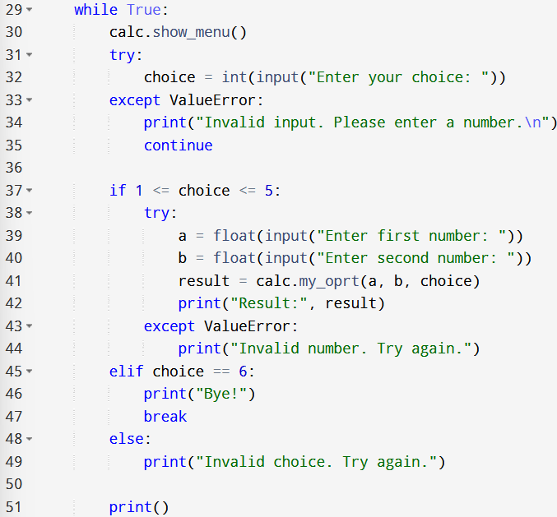
Additionally, for the if _name_== “_main_”: it ensures that the main() function only runs when the script is executed directly.
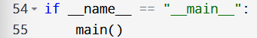

Moreover, here’s a few snippets of the output of the program
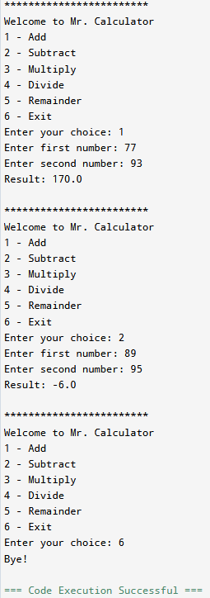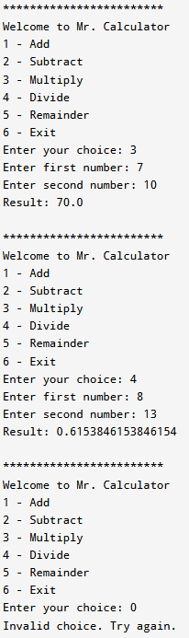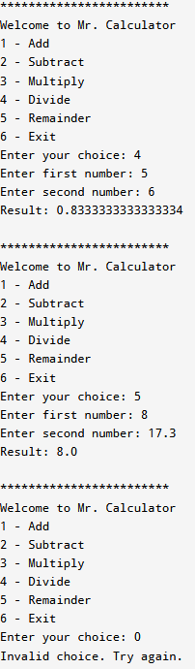

Lastly, this code we or I had done is a menu driven calculator program, that makes use of the Object-Oriented Programming (OOP), allows User Input, and utilize Simple conditions to handle the five basic operations (Add, Subtract, Multiply, Divide, and the Remainder) as well as handling the invalid input from the user.

